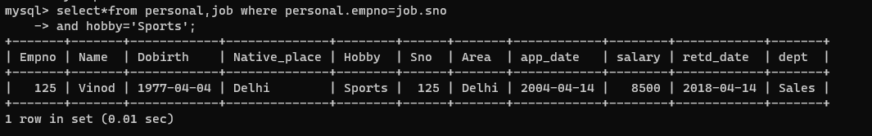1)

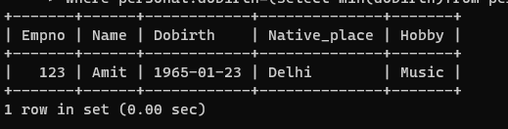 2)

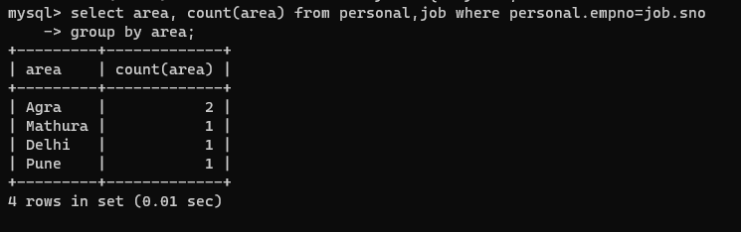3)

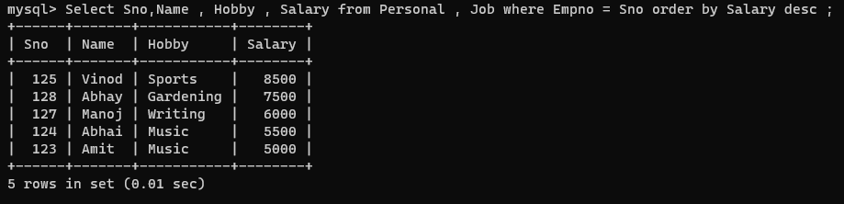5)

6) 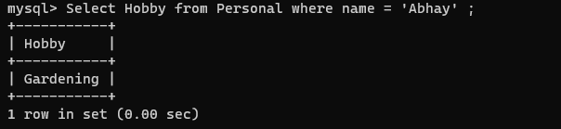

7)

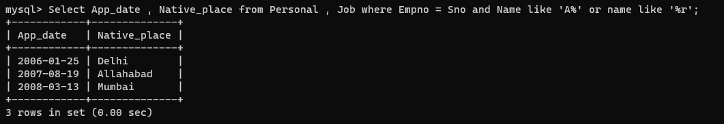

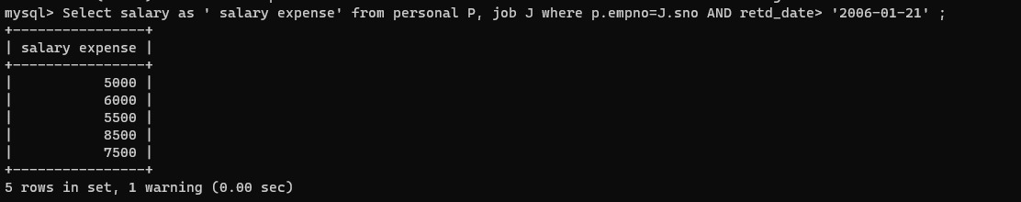8)

9) 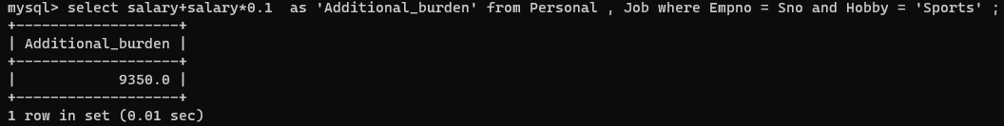

10) 

11)

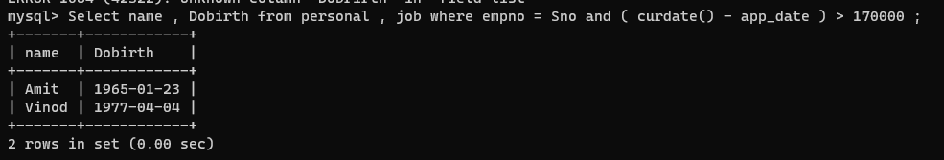12)

13

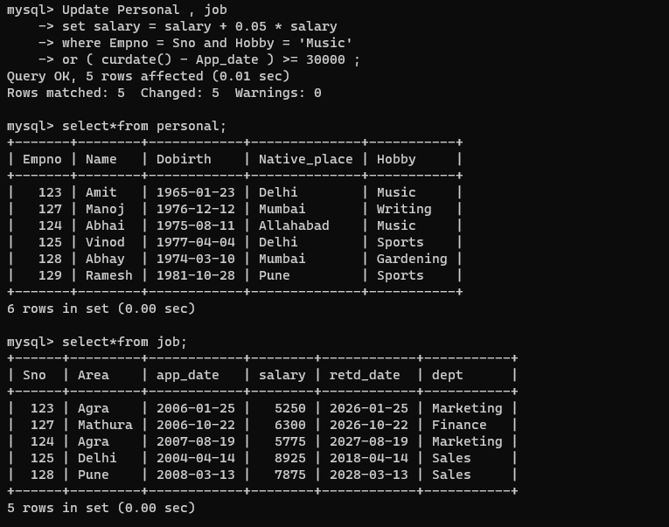14)   
a)

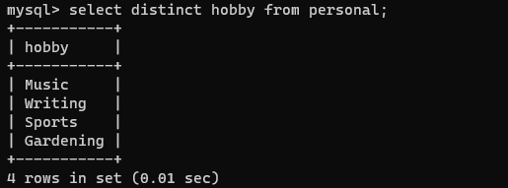

b) 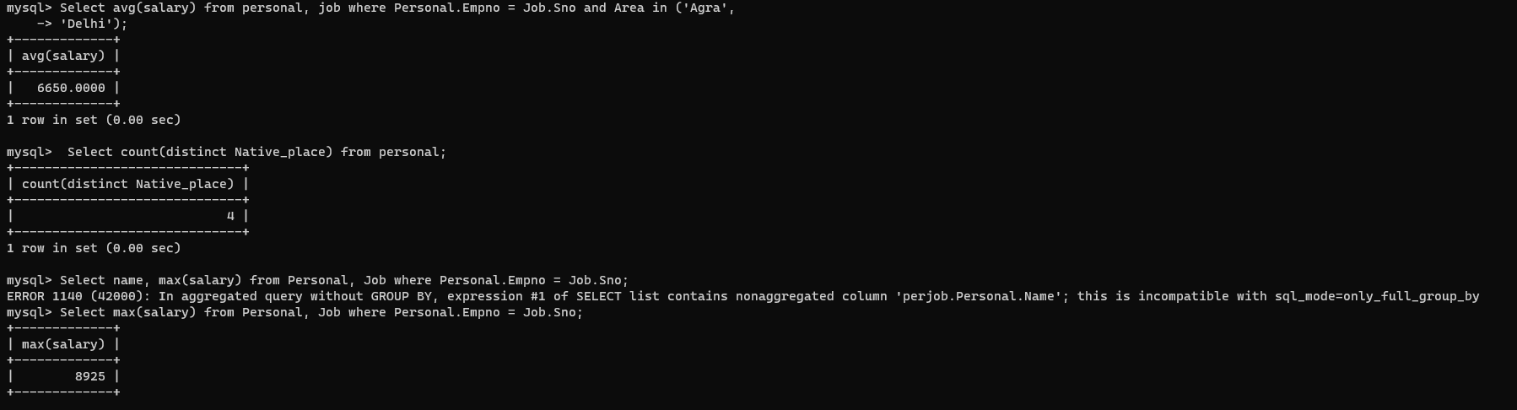

15) Insert into Personal (Hobby) values (135,"PathWalla", 20081990, "Lucknow" “Music”);

16) Alter table Job add column email char(100) ;

17) Create table new_table (Select Empno , name,Hobby from Personal);

18) Select * from personal , job where empno = sno and ( retd_date - app_date ) < 150000 ;

19) Delete from job, personal where empno = Sno and hobby < >  “Sports” ;

20) Drop Table Personal;